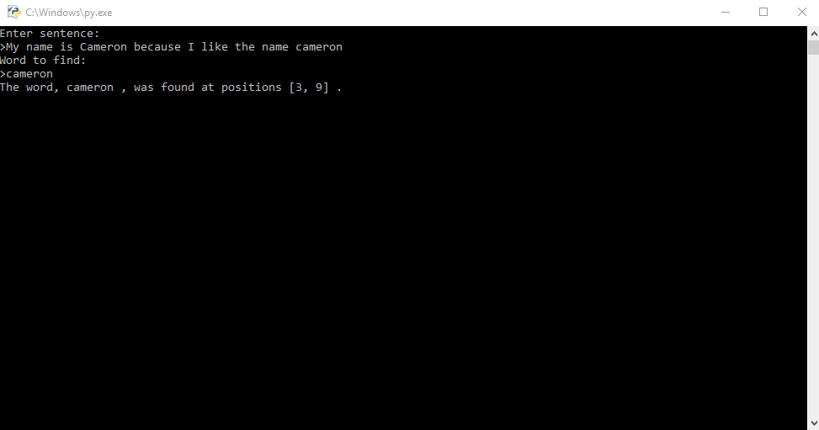

Test: Entering a sentence containing a word with punctuation on the end

Expected outcome: Position of word

Actual outcome: Word not found error

Improvement: Add punctuation compatibility

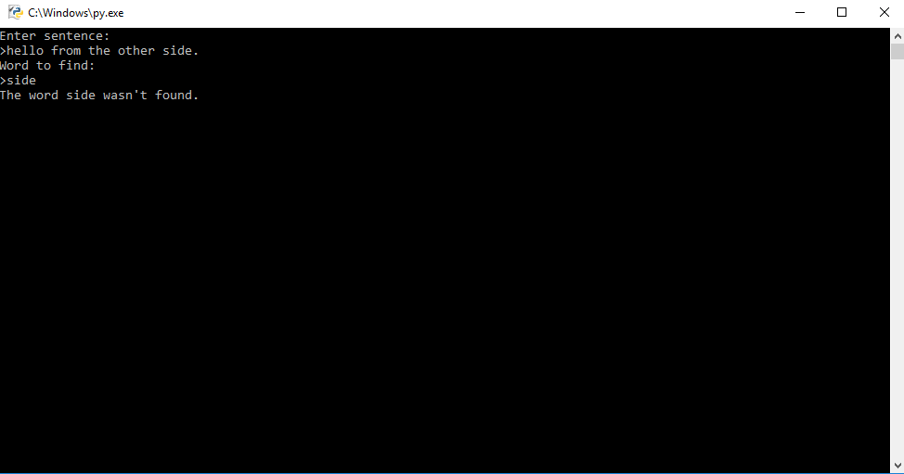

Test: Entering a sentence with the same word used twice and searching that word

Expected outcome: Both positions of the word in the sentence outputted

Actual outcome: Both positions of the word in the sentence outputted

**Task 1 Test plan**

Test: Inputting nothing

Expected outcome: Warning to user then loop back to input

Actual outcome: Warning to user then loop back to input

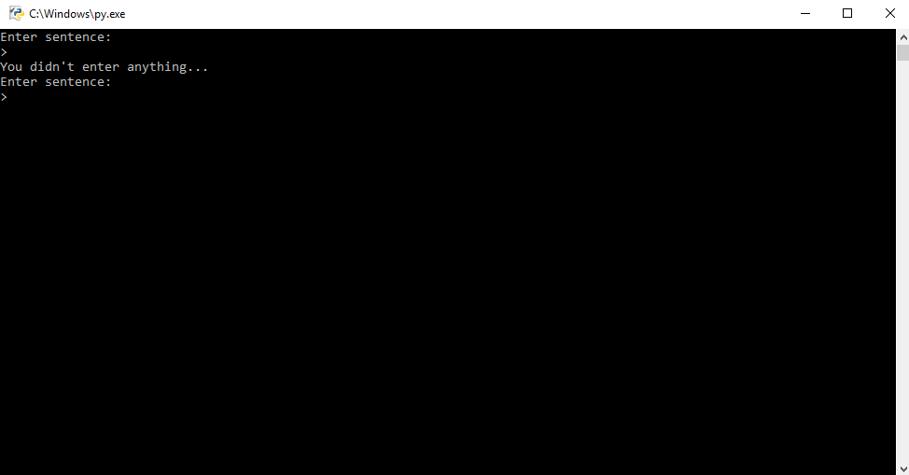

#Welcome screen of task 1

